**PART II: NETWORK**

1. **Parachains: Explore parachain-related activities.**

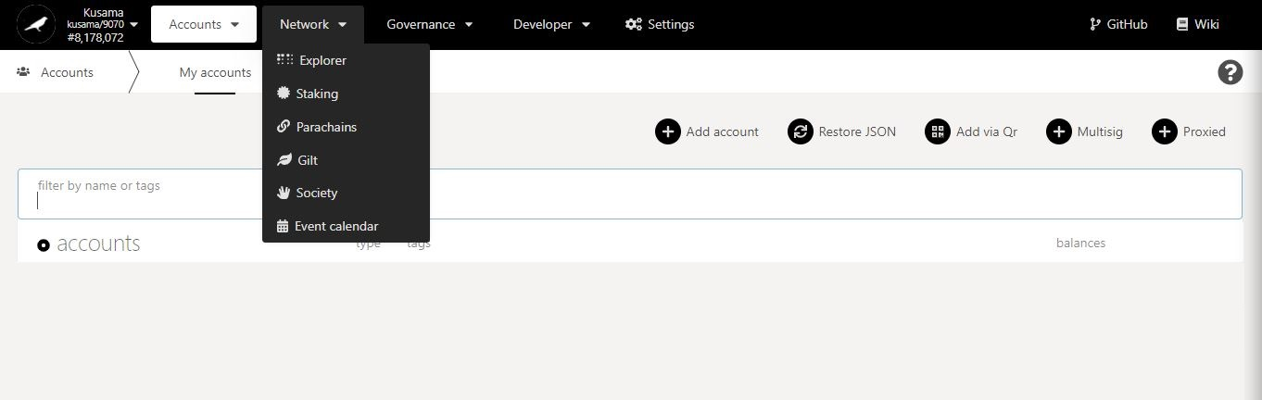

* 1. **View general parachain information.**

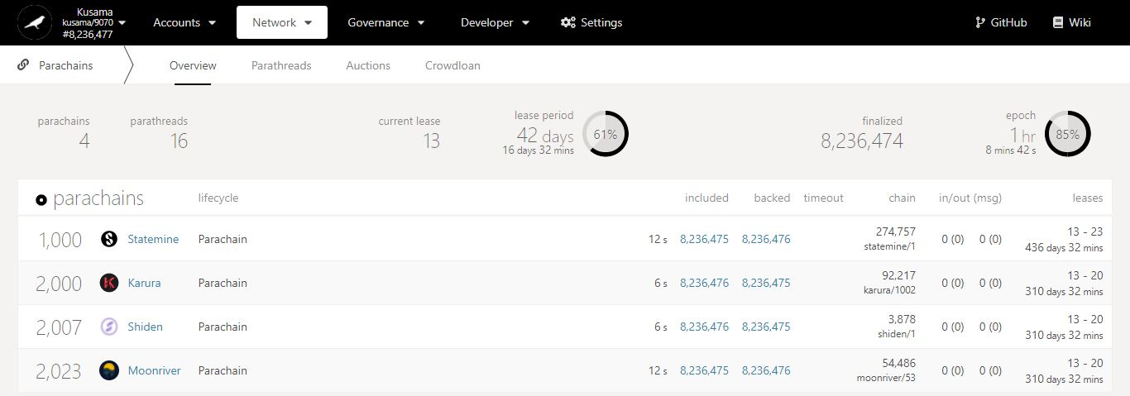

Key information on parachains: **waiting parathreads, current lease period’s ID, and lease period’s duration.**

Parachains summary:

- **Included:** Blocks produced by parachain collators.

- **Backed:** Blocks validated by relay chain (para)validators.

- **Chain:** Parachain runtime (chain spec) versions.

- **In/Out (msg):** Cross-chain messages sent/received by the parachain.

- **Leases:** Lease period IDs allocated to the parachain (when it obtained a slot) and their total duration (in days and minutes).

**Parachains** or **Parathreads**?

Registered **ParaIDs**.

Registered **names**.

* 1. **View onboarded parathreads.**

1. Click **Parathreads**.

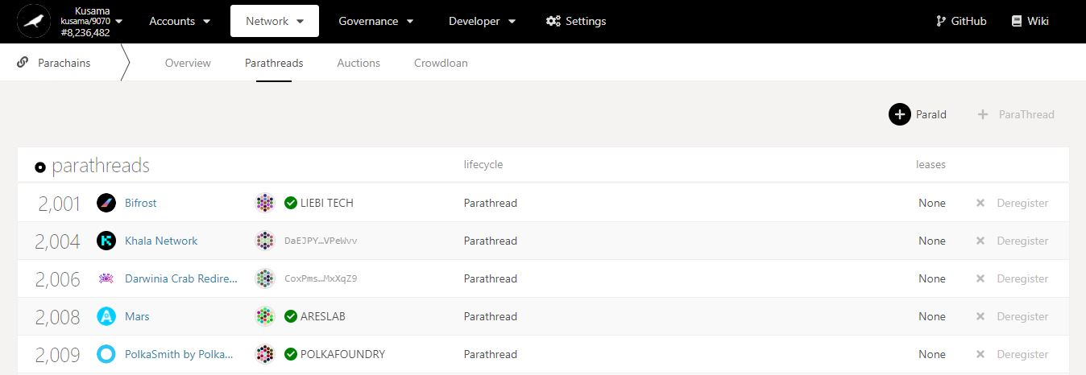

2. Click **ParaID** to register your network as a parathread.periods **obtained.**

Registered **names**.

**Parachains** or **Parathreads**?

Registered **ParaIDs**.

Leaseperiod IDs **obtained.**

Addresses of currently **registered parathreads**.

**NEVER SEND YOUR KSM TO A PARATHREAD’S ADDRESS!**

* 1. **View auctions’ progress.**

1. Click **Auctions**.

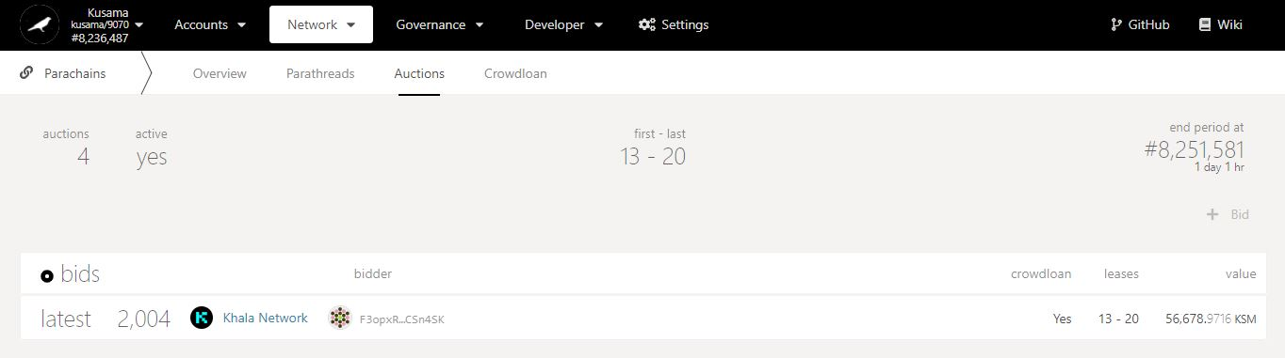

Countdown to auction’s end period (during which the winning bid will be determined).

Key information on auctions: **auction number, activity, lease period IDs, and timings.**

Is there a crowdloan campaign **associated to this bid**?

2. Check the latest bid(s) **included in recent blocks.**

**Targeted** leaseperiod IDs.

KSM amount **submitted for this bid.**

Addresse(s) of current **bidder(s)**.

**NEVER SEND YOUR KSM TO A BIDDER’S ADDRESS!**

* 1. **View and contribute to crowdloans.**

1. Click **Crowdloan**.

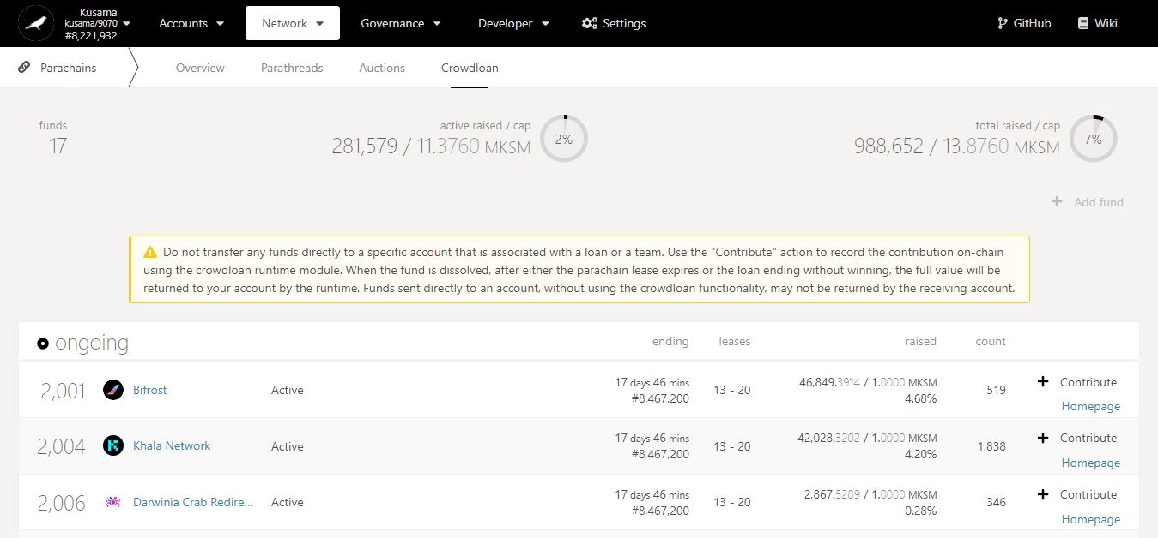

Time is left **to fund a crowdloan** and **win an auction.**

2. Double-check **warning messages.**

Key information on crowdloans: **active funds, and KSM amount locked in funds.**

KSM amount raised by each fund **out of its total desired cap.**

3. Click **Contribute** to lend your KSM to a fund.

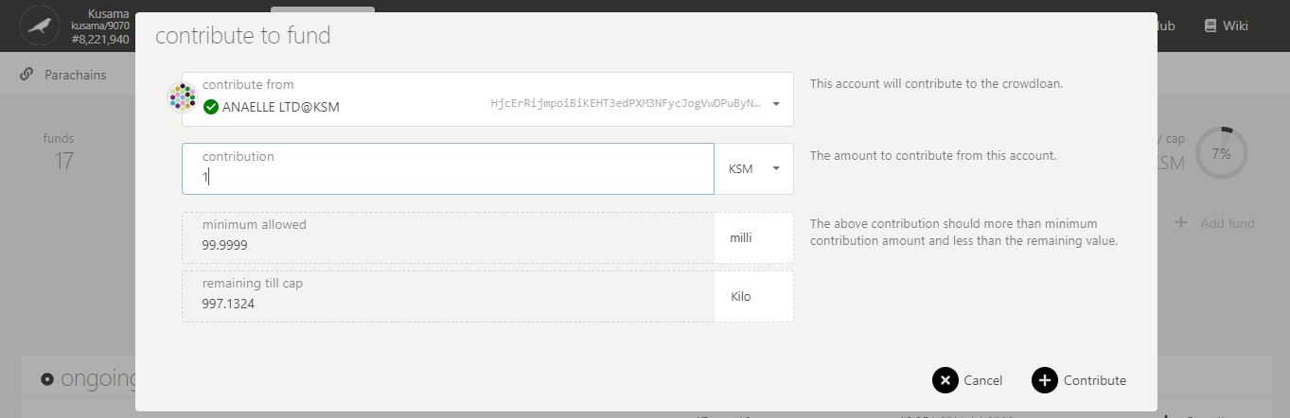

5. Click on **Contribute** to continue the procedure.

**Minimum** crowdloan contribution is **0.1 KSM**.

4. Follow **on-screen instructions** carefully.

**Nature** of the transaction.

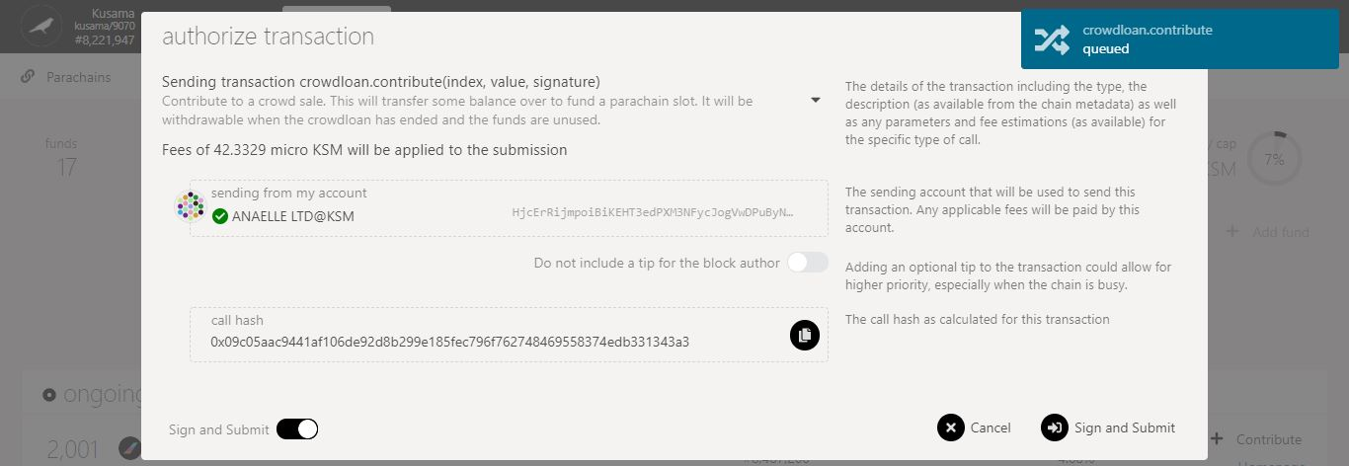

6. Check the **transaction fees**.

7. Click on **Sign & submit** to continue the procedure.

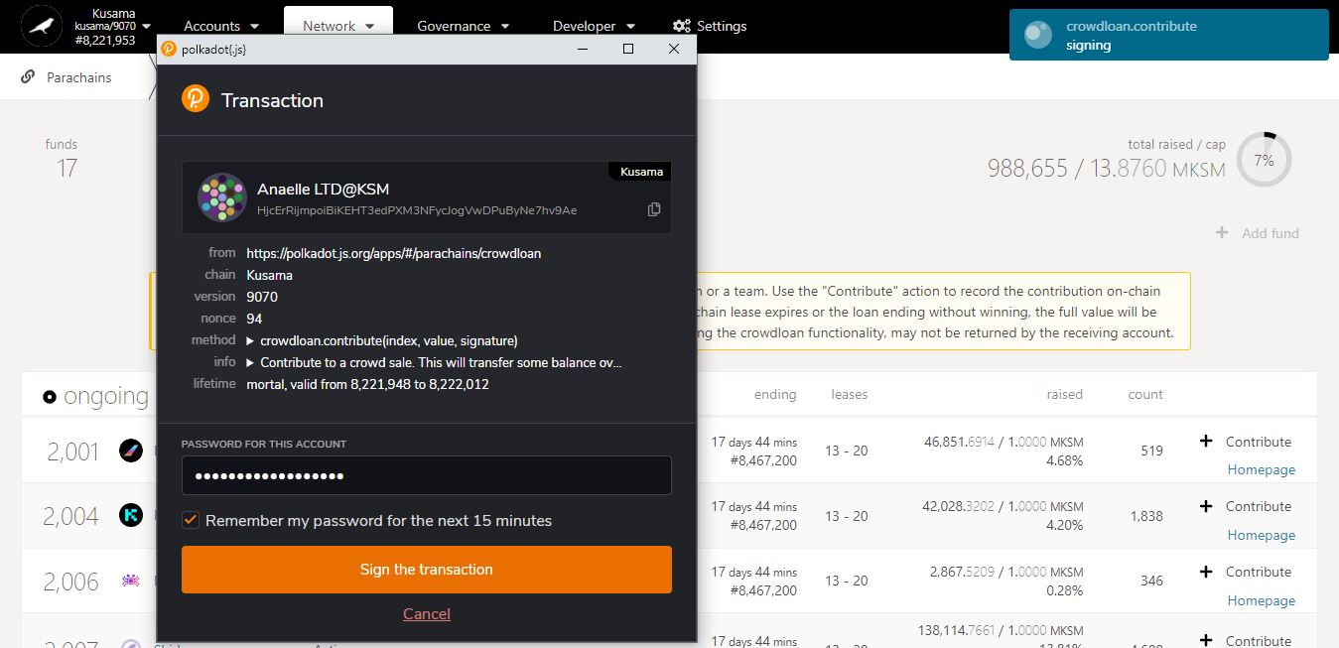

**Progress** of the transaction.

9. Click on **Sign the transaction** to complete the procedure.

**Summary** of the transaction sent via the Polkadot-JS extension.

8. Enter **your account’s password** and tick the box to **remember your password, if necessary**.